**Sign language recognition**

**Miroslav Košpić**

1. Motivation

Sign language is important field in Machine learning . My motivation came from one of my studnet. I was teaching programming language Python for freshmen, and one boy had a little bit difficulty with talking and hearing my lectures. After a few days of teaching, i got an idea to make this program, which will help people to communicate via sign language.

2. Research questions

Problem which i wanted to resolve is Sign language recognition. Dataset is handmade by author. Dataset contains over 5000 pictures of hand. Every letter of alphabet has around 200 pictures. 30 pictures of every letter are used for test dataset, and others are used for train dataset. For purpose of project, from 5000 pictures i made 2 csv files. One csv file for test, and another for train data. At the beginning pictures were colorful, but because of need, script was made which transforms colorful pictures in black and white. White color is used for hand, and black color is used for background of picture. Size of pictures is 300x300 pixels, but they are converted in dimensions 100x100 before training .

Example of dataset:

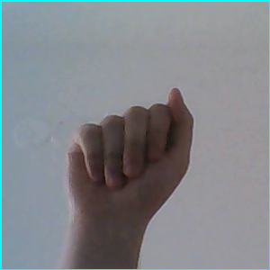 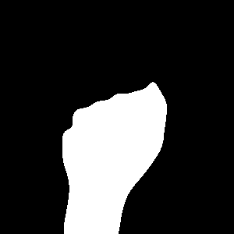

Letter A Letter A( transformed )

3. Related work

A lot of authors are trying to implement the best possible solution. Before implementation of project, i was examining a few other related works. Everyone have public git repository, so it is easy to find other solutions. Some of them did the same thing like me and make own pictures (dataset). They are also authors who used datasets from interent (already made datasets). They are authors who used alredy trained network made by Google themselves.

Every one got a different idea, which leads to similar result. Problem is the same for everyone, and thats color of background. If you have background with color similar to your hand, you will have a difficulty recognizing skin.

4. Methodology

My approach for this problem was simple. I used same Python libraries, which i used in the past for project in Machine learning. Libraries are pandas, numpy, keras, tensorflow, openCV, csv, os. One new Python libary, which i didnt use in past, is PIL libary. I used it for loading images from my hard, and converting it into csv files. Also because applaction is GUI, i need some libary for that too. I used PyQt5 which is great tool for such a job. For network i used CNN (Convolutional Neural Network).

X values were pixels of images, Y values were classes(26 letters).I normalized X values (pixels) to get them in range 0-1. For Y values i used one hot encoding to get 0 to 25 numbers for recognition instead of ABC...Z. Accuracy of network was over 98% which is good. Model was trained fit 10 epochs with batch size of 200.

The network topology can be summarized as follows:

1. Convolutional layer with 32 feature maps of size 5×5.

2. Convolutional layer with 32 feature maps of size 5×5.

3. Pooling layer taking the max over 2*2 patches.

4. Dropout layer with a probability of 25%.

5. Convolutional layer with 64 feature maps of size 3x3.

6. Convolutional layer with 64 feature maps of size 3x3.

7. Pooling layer taking the max over 2*2 patches.

8. Dropout layer with a probability of 25%.

9. Flatten layer.

10. Fully connected layer with 256 neurons and rectifier activation.

11. Dropout layer with a probability of 20%.

12. Output layer.

5. Discussion

When program is runing you can see square 300x300 pixels where you are supposed to put you hand. Below is picture of program.

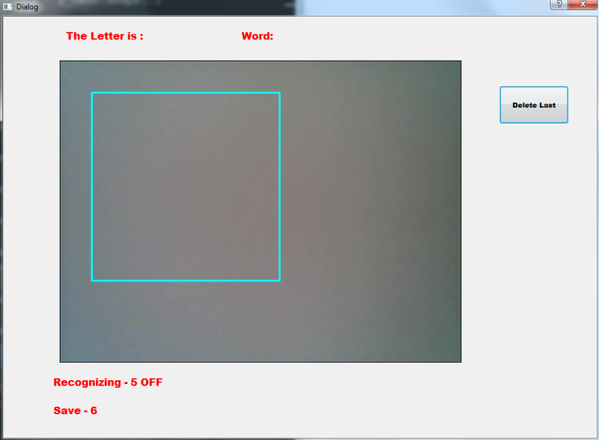

When you press number 5 on you keyboard, then program will go in recognizing mode and it will start scanning shape in blue square. In label at the upper left corner you can see current letter ( letter that program recognized from your hand ). After that if you agree with choice you can press number 6 and save letter. Your whole word will appeard at the upper part of window. Also if you want you can delete last letter of word. I tested this application with my girlfriend, and we got good results.

Program was learning with hand of author, but it is capable of recognizing hand from others. Issue that i run into is when im trying letters (A, E, S). They are very similar in sign language, so sometimes program will recognize them wrong ( you will think is wrong), so you have to adjust your hand a little bit better for getting letter you want.

6. References

1. https://docs.opencv.org/2.4/index.html

2. https://machinelearningmastery.com/handwritten-digit-recognition-using-convolutional-neural-networks-python-keras/

3. http://pyqt.sourceforge.net/Docs/PyQt5/

4. https://docs.scipy.org/doc/numpy/